Exercise 4 – Creating Relational Models

The purpose of this lab, given business rules, is to provide practice for the creation of relational models.

# Part A – Completed with Instructor

## Problem 1

A small brokerage firm needs a database system to record stock transactions when clients make purchases or sales (called trading) in the stock market. Customer’s do not trade stocks directly but use a broker. Data needs to be kept on each broker, each client, and each stock trade.

Draw the data model as described here using MySQL Workbench.

Entities and attributes that need to be included (other items may be necessary):

* Brokers: broker full name, salary, how long they have been employed
* Customer: Full name, address, join date, account balance, type of client (**I**ndividual, or **C**orporate)
* Stocks: stock code, stock name
* Trade: time and date the trade was made, number of shares (called volume), price paid.

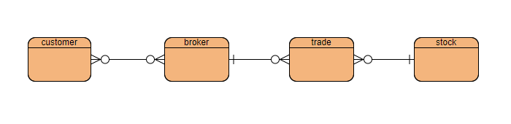

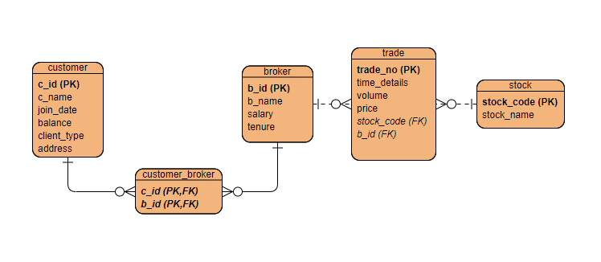

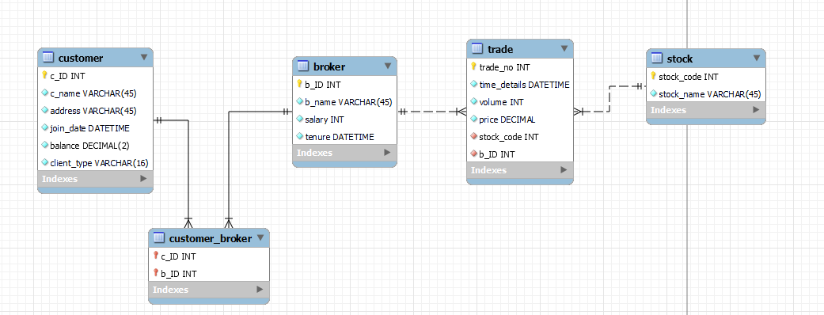

## Problem 2

Consider the following logical model of a movie theatre:

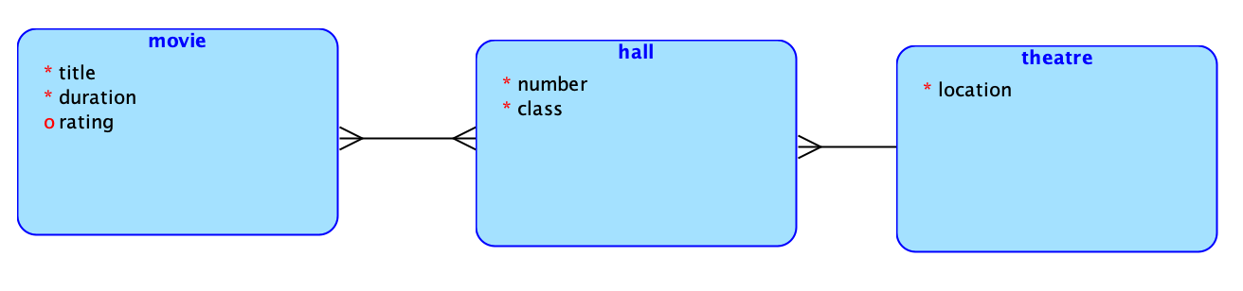

Draw the physical ERD by hand or using draw.io. Do not use MySQL workbench for this exercise! This exercise is about knowing where to put primary and foreign keys. There will be a question on the midterm/final like this exer cise and you will have to do it by hand.

# Part B – Additional Exercise

## Problem 3

A company has a range of products for sale to customers, and for the products that it sells, it has suppliers. E.g., think of IKEA or ACE or Lulu. Based on the following brief description of operations, create the appropriate fully labeled Crow’s Foot ERD.

* A customer can order one or more products. For example, you could order one chair of a certain model from IKEA. Or you might order many more chairs.
* The name, address, gender, and date of birth of customers are tracked so that relevant marketing messages could be sent to the customer on their birthday.
* For each order placed by a customer, a product (by ID), date of the order, how many of it the customer needs and the total cost amount is tracked.
* A product at the store must be purchased from a supplier. Therefore, other than the product ID, its name and the supplier’s ID should be recorded.
* A supplier can have many different products. It is possible for a supplier to be in the system even if they don’t currently have any products to sell.
* Other than an ID, the name of the supplier and a contact person needs to be tracked.

## Problem 4

A library wants to digitize its management system to track books, members, and book loans. Based on the following description of operations, create the appropriate physical model ERD.

* The library stores books that can be loaned to members. Each book has a unique ISBN, title, publication year, and catalog number.
* Members who borrow books have a unique membership number, name, phone number, email and the date they joined the library.
* When a book is loaned out, the library must track the date that the item was borrowed, the due date, and the actual date that the book was returned.

